|  |  |
| --- | --- |
| **Date** | **10 November 2022** |
| **Team ID** | **PNT2022TMID00940** |
| **Project Name** | **SMART SOLUTIONS FOR RAILWAYS** |

# **SPRINT-4**

**WEB APP CREATON AND TESTING**

**An IOT device “GPS” is created at IBM Watson:**

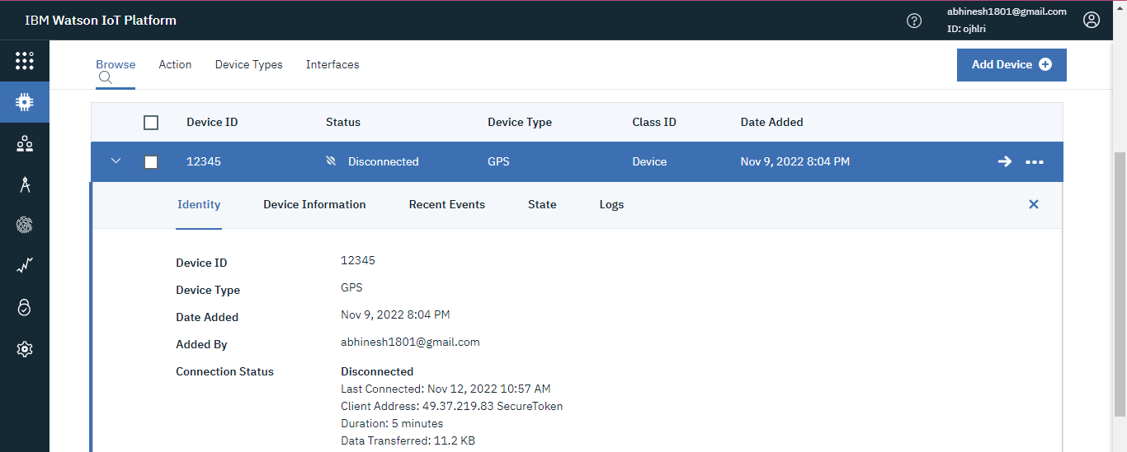

**Creating a Node-Red Connection using the IBM IOT (connected with GPS(IBM Watson device) ) for tracking the location of the train:**

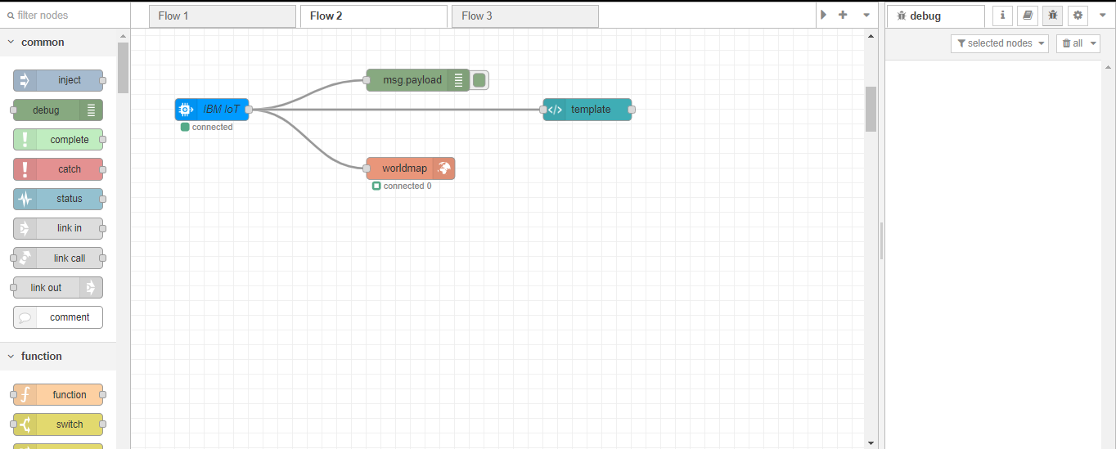

**Creating a WEB UI with Node-Red to see the location:**

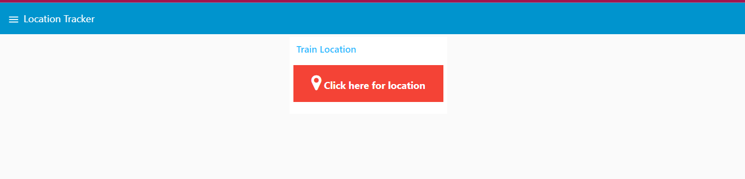

**Link:**

[**https://node-red-gitmx-2022-11-08.eu-gb.mybluemix.net/ui/**](https://node-red-gitmx-2022-11-08.eu-gb.mybluemix.net/ui/)

**Connecting the GPS Device with our Python Code to stimulate the locations:**

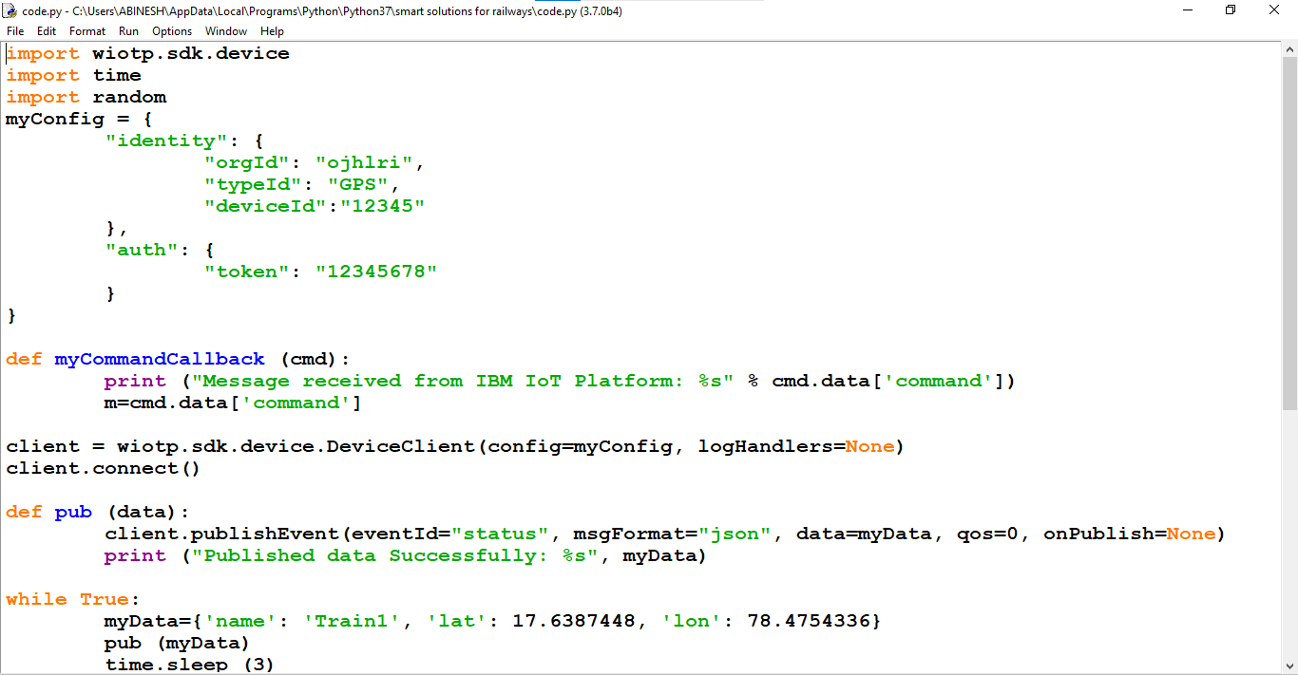

**After linking ,the python code is made to run at python IDE:**

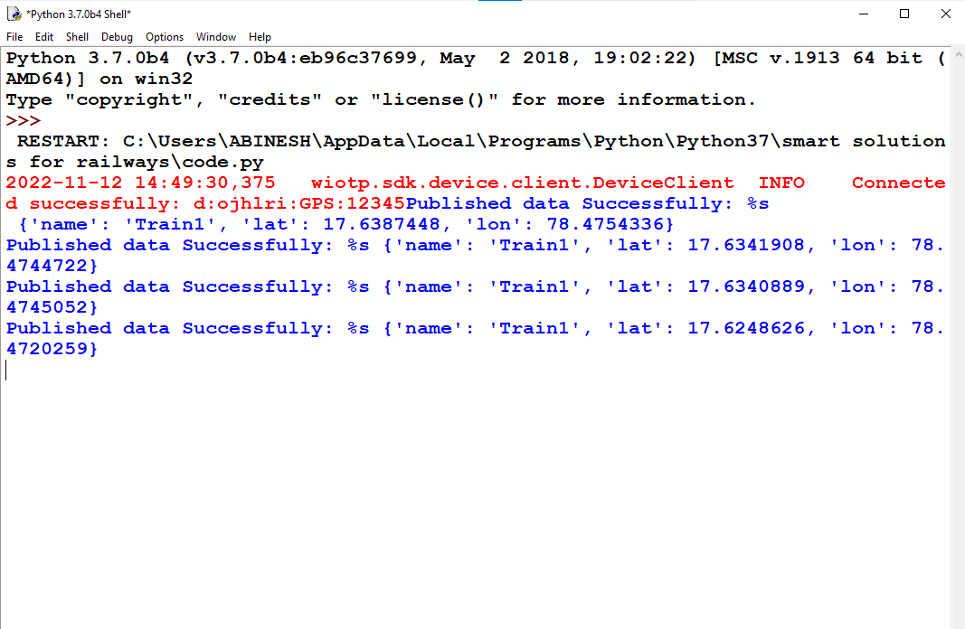

**The IOT Device is conneted and the locations are Received as output.**

**Watson Output:**

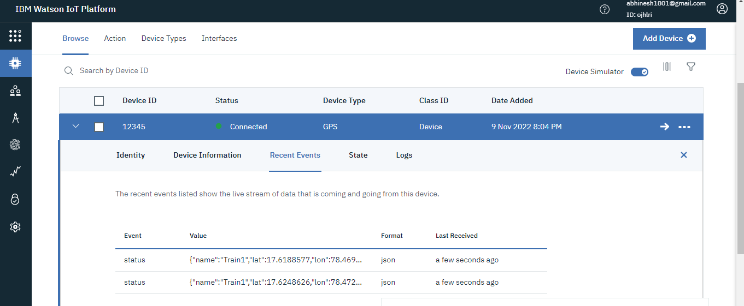

**Initially before the execution of python program:**

**No location found,**

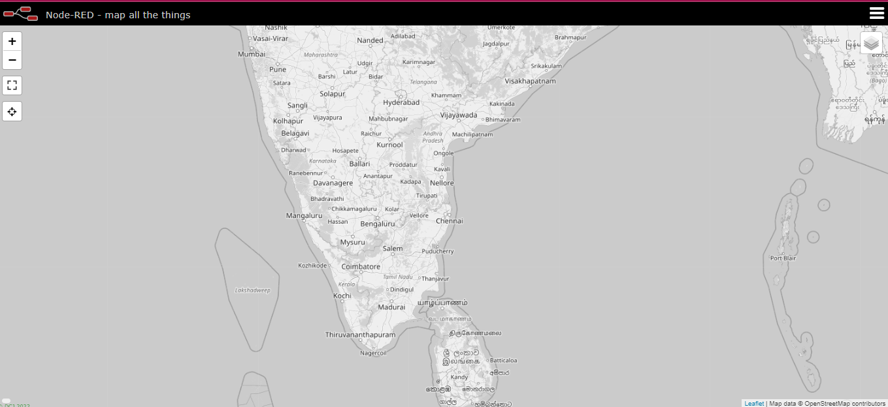

**After execution,**

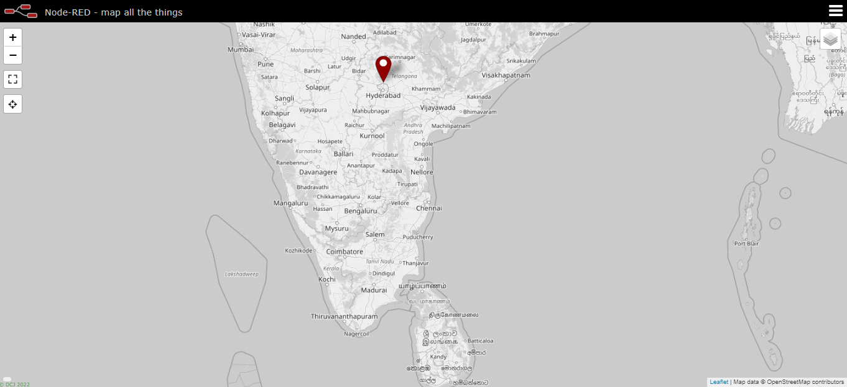

**Below Four images of map show the movement of the train:**

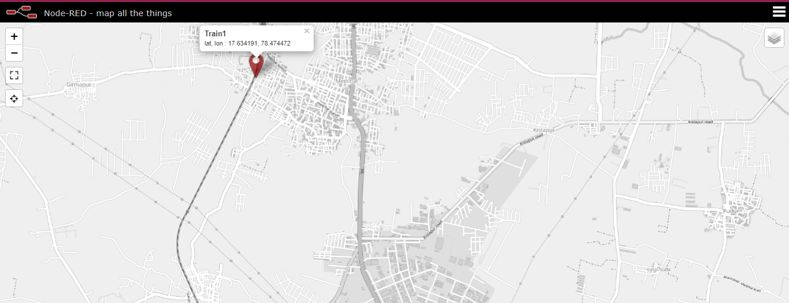

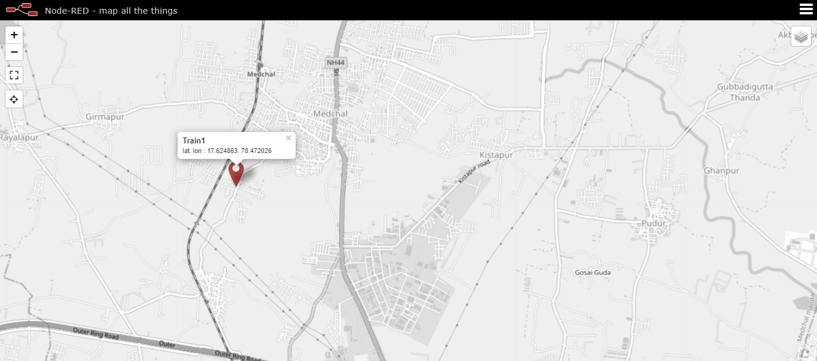

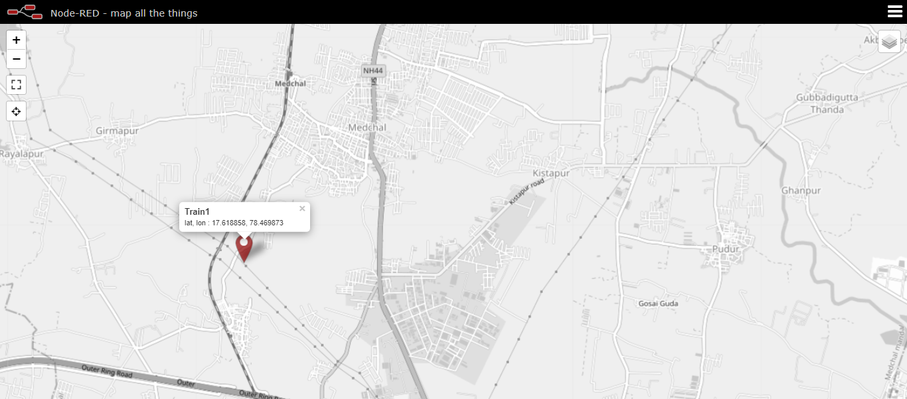

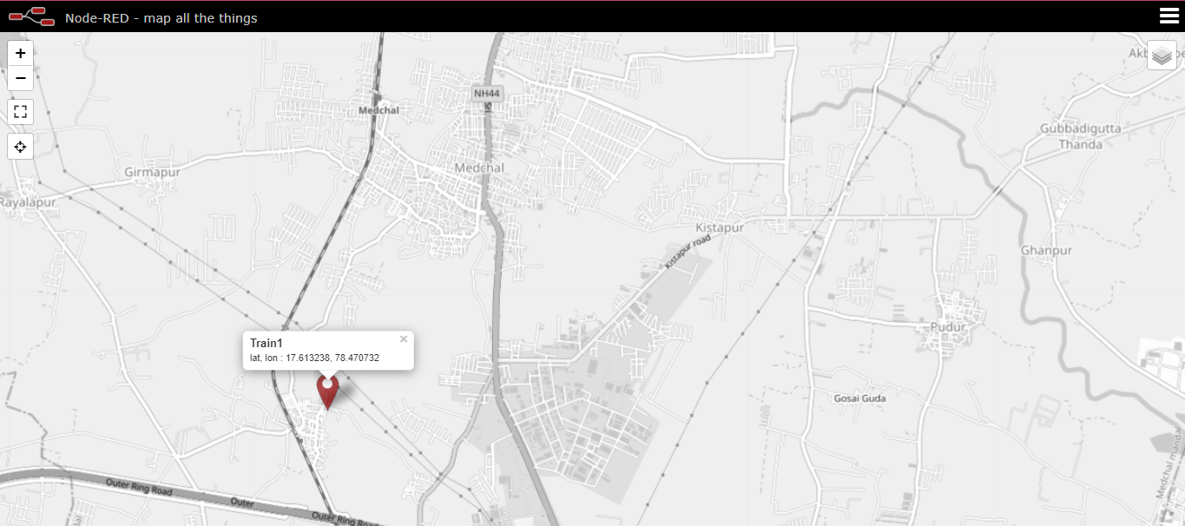

**LINK FOR THE MAP VIEW:**

[**https://node-red-gitmx-2022-11-08.eu-gb.mybluemix.net/worldmap/**](https://node-red-gitmx-2022-11-08.eu-gb.mybluemix.net/worldmap/)

**WEB UI for Ticket Booking and QR Code Generation**

**Node-Red Connection for Ticket Booking and QR Generation:**

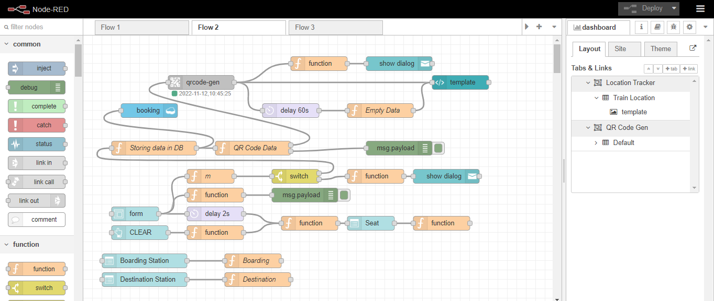

**Creation of Cloudant Database Named “Booking” to store Customer details:**

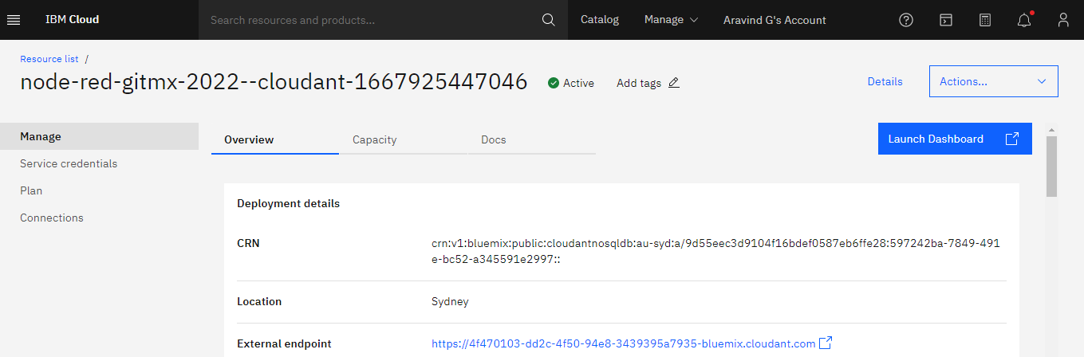

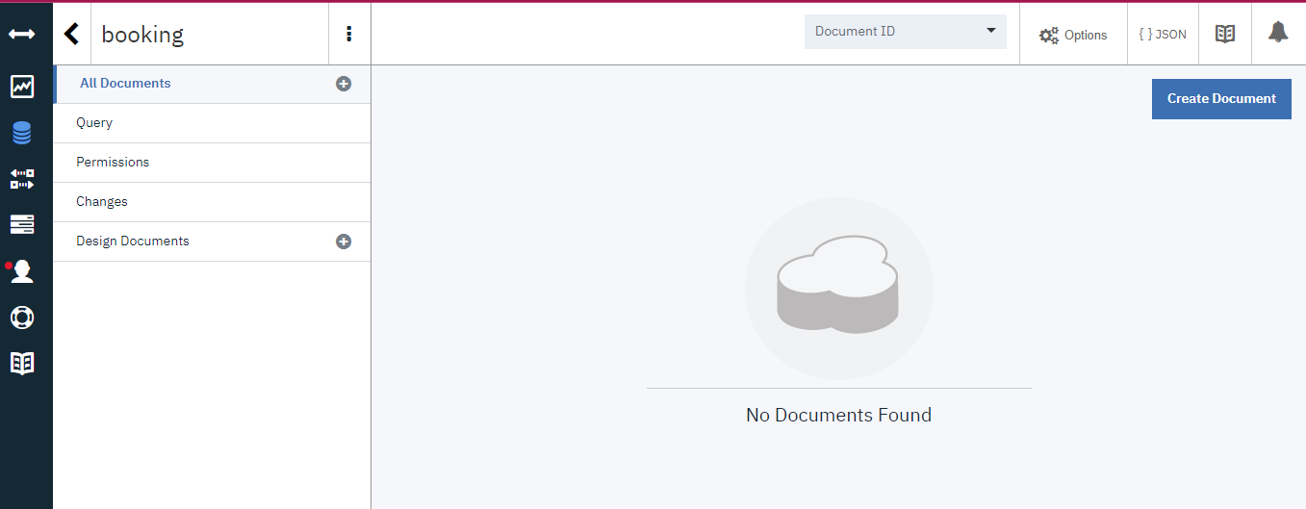

**WEB Application created from Node-Red:**

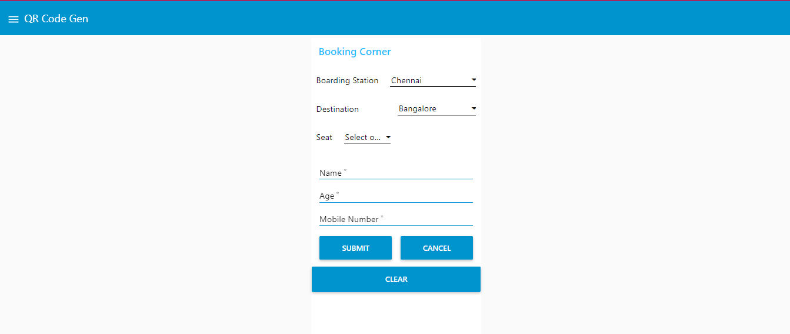

**LINK FOR Booking Corner:**

[**https://node-red-gitmx-2022-11-08.eu-gb.mybluemix.net/ui/**](https://node-red-gitmx-2022-11-08.eu-gb.mybluemix.net/ui/)

**Booking Happens :**

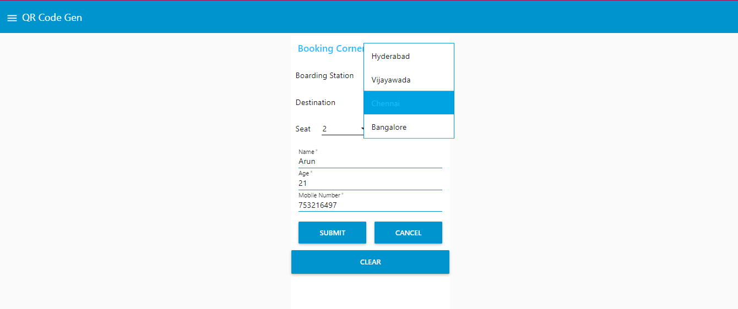

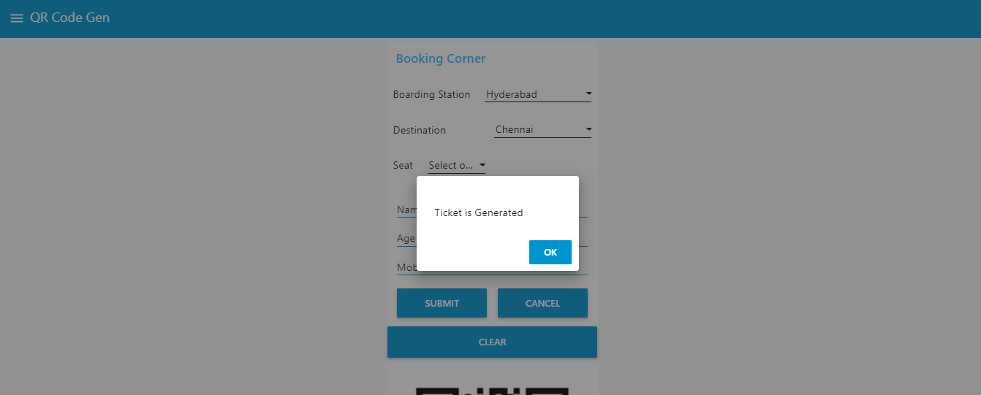

**QR Generation:**

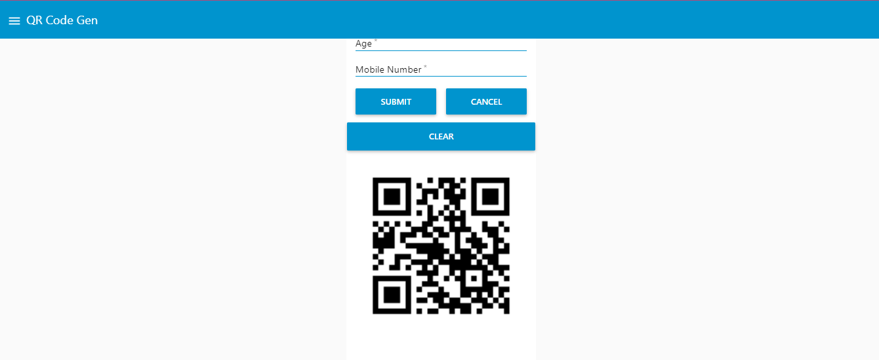

**Details will be stored at Cloudant Database:**

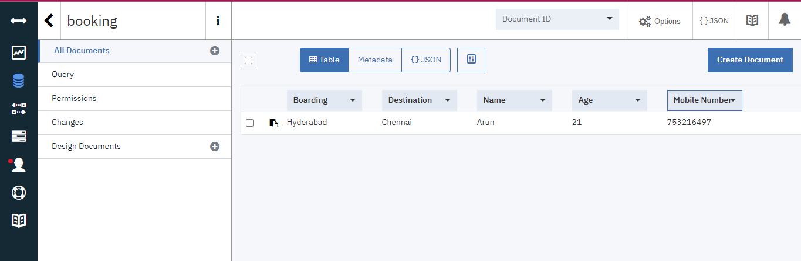

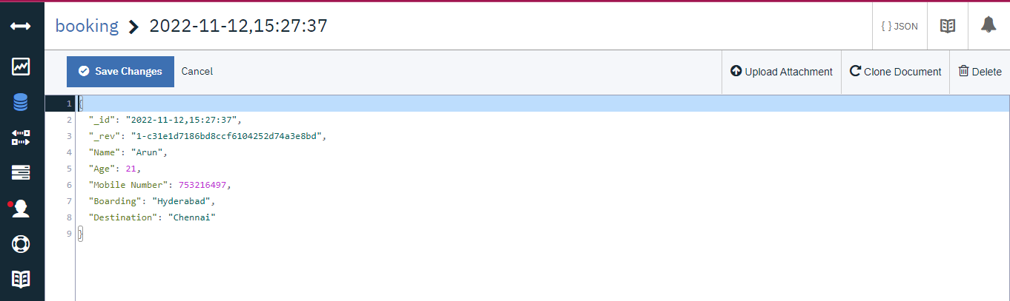

**Building a python code for the Ticket Collector to scan the QR and get details from Cloud:**

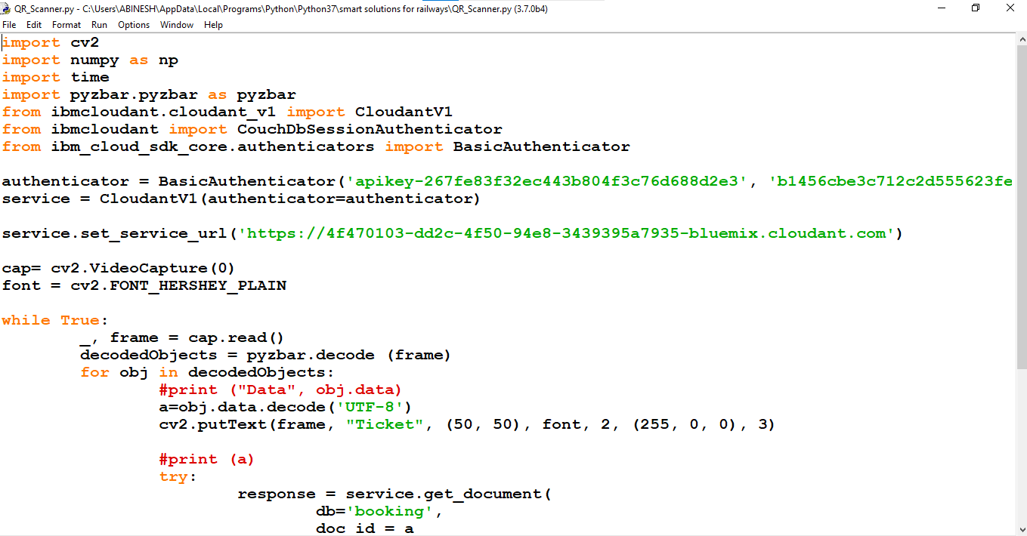

**TESTING:**

**Executing the program:**

**Scanner Opens :**

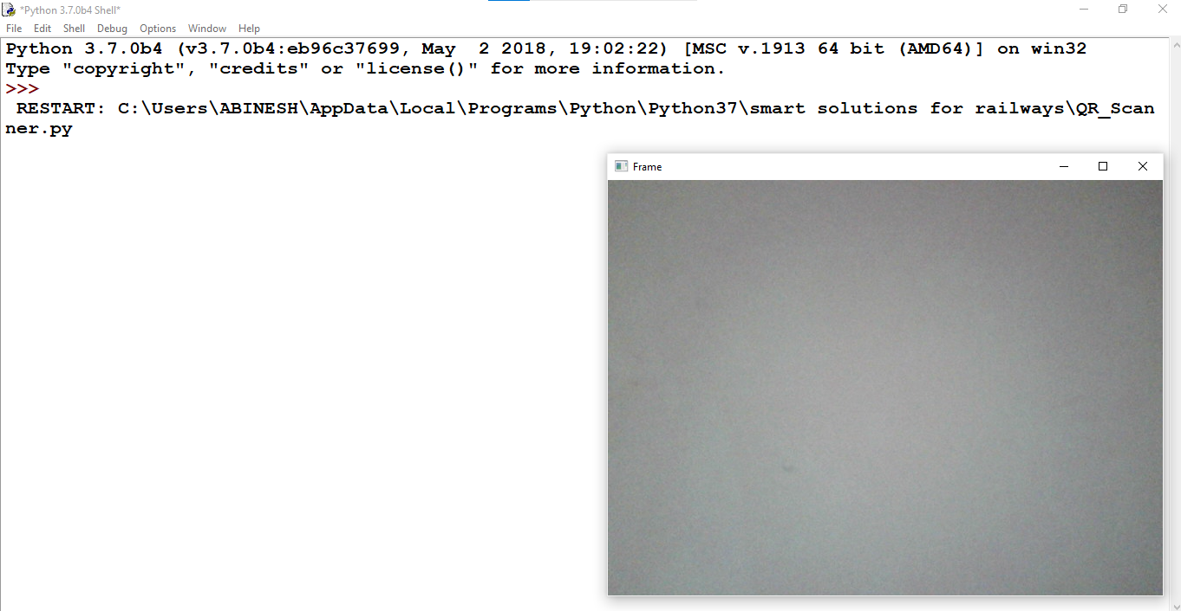

**QR is shown:**

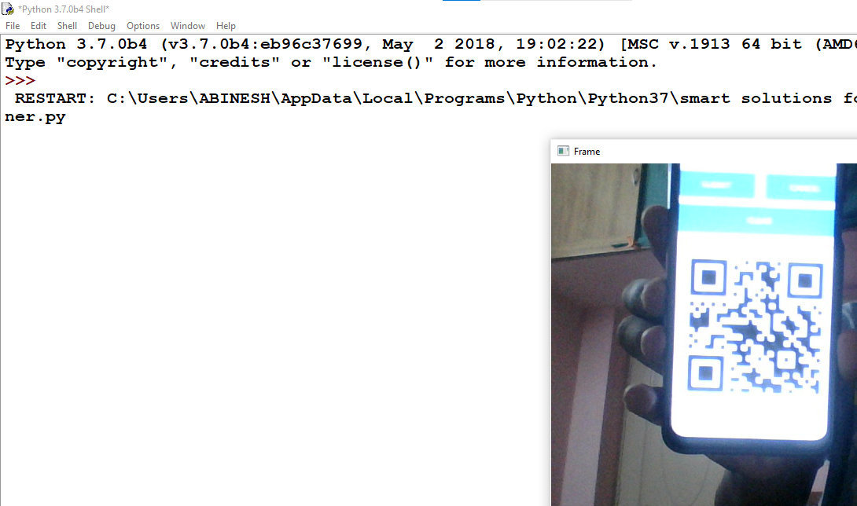

**Data Fetched from Cloud by scanning the QR:**

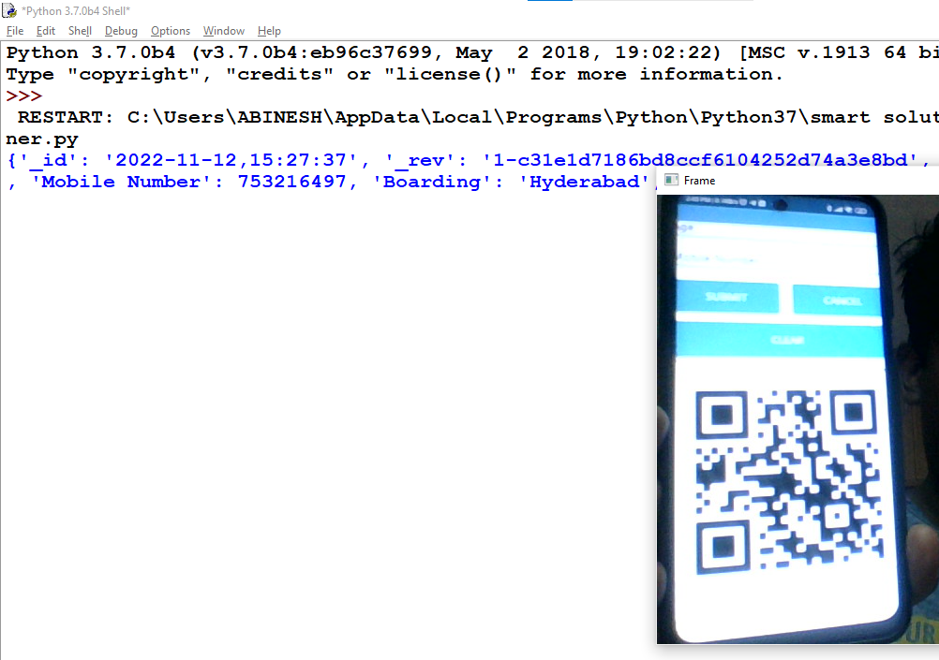

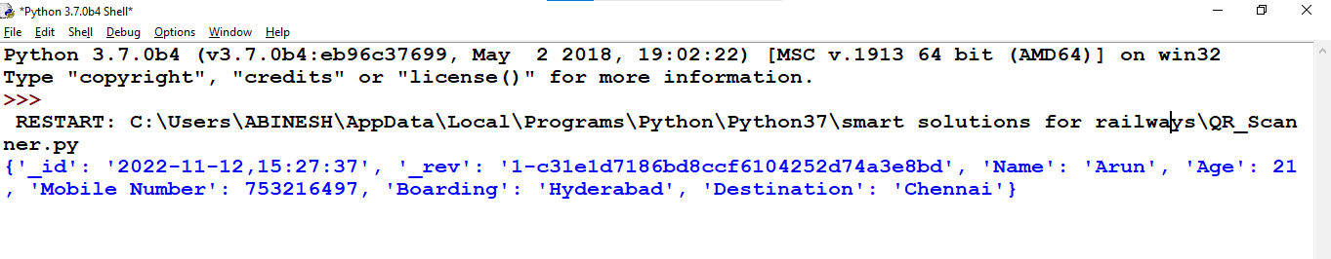

**Showing a Random Qr From Google:**



**Output: (Shows “Not a Valid Ticket”)**

